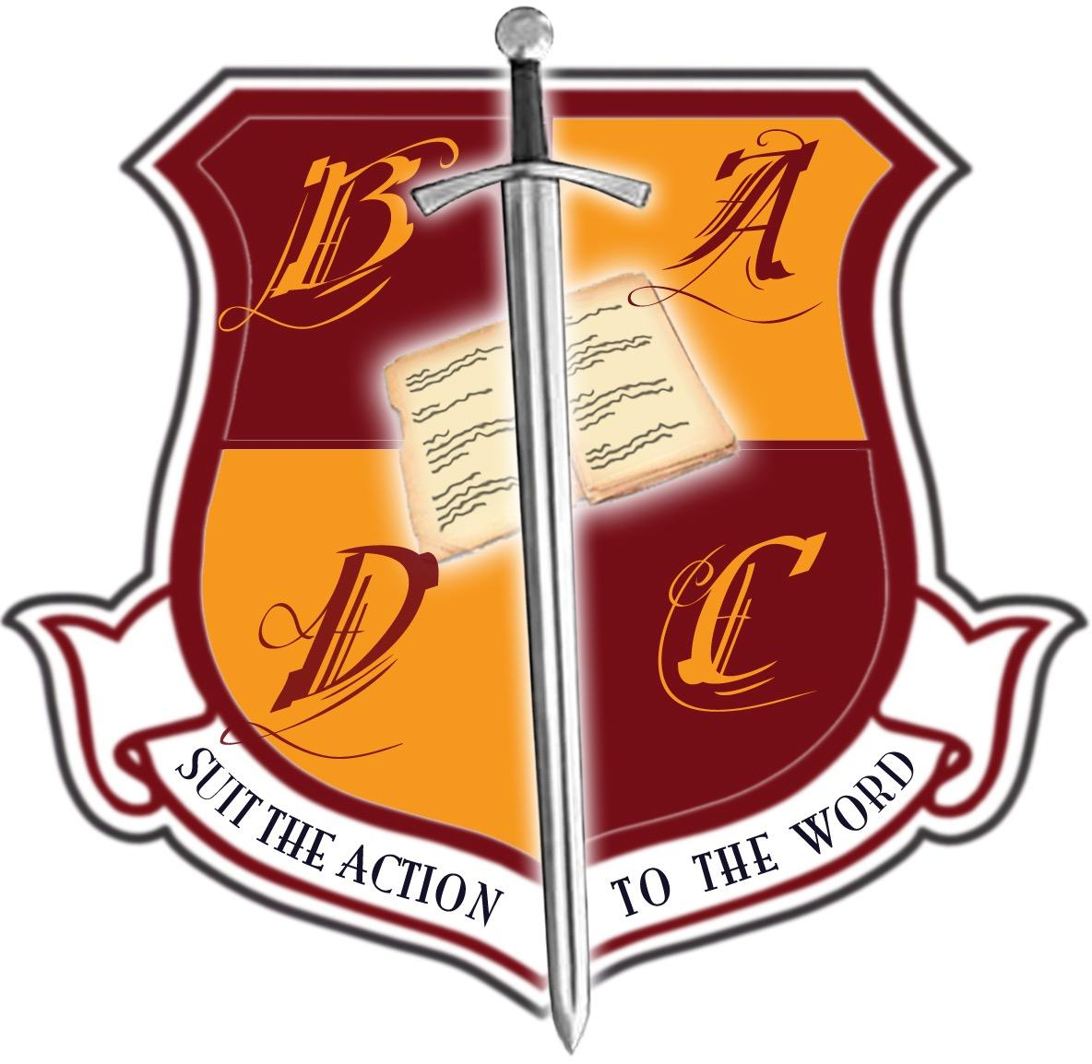
BRITISH ACADEMY OF DRAMATIC COMBAT

New Syllabus Proposal Form

Please use this form if you would like to propose a syllabus for a new weapon system to be considered for use with BADC examinations. Once all sections have been completed the form should be sent to the BADC Committee as an email attachment to: info@badc.org.uk

NB: Only weapon systems which have a syllabus that has been approved and validated by the BADC Committee may be used in BADC Examinations.

- Name of weapon system
- Recommended type/make of weapon to be employed
- Rationale
[Provide a rationale for the inclusion of the weapon system as a BADC syllabus. Give information regarding the relevance of the system to performance combat training and the prevalence of the system’s use in theatre, television, film or other media]
- Background information
[Provide a short introduction to the weapon system giving information about the historical and cultural contexts of its use]
- Useful resources
[Provide a list of reference materials which cover use of this weapon system. This may include texts on historic or dramatic application, filmography and websites if appropriate]
- Level of Syllabus
[Indicate the level at which the weapon system is to be examined by ticking all applicable boxes]

□ Foundation
□ Standard
□ Further Level
- Reasons for choice of level(s)
[Provide a short statement to explain the level/s proposed]
- Core techniques
[Provide a list of core techniques that should be covered in any course that uses this weapon system. Indicative headings are provided below, but please add your own entries as necessary]

Footwork:

Attacks:

Defence:

Attacks with avoidance:

Prise de fer:

Grips:

Floor work:

Other:

      - Teaching Notes
[Provide additional information about the teaching of specific techniques and variations where applicable]
      - Health and Safety
[Provide additional information regarding specific health and safety issues related to the teaching and practice of the proposed weapon system]

© British Academy of Dramatic Combat, May 2023

